Conversion of a Marconi Blue Cap LNB into a 3cms 30-50mW Tx.

These mods. are based on the article by Bob Platts, G8OZP, in CQ-TV 181 P64-68.

In this variation the various bias voltages are generated from the onboard PSU as used by the LNB. Hence there is no reason to create a separate board generating the 4 voltages. Bob believed that the internal circuit was not capable of supplying sufficient current, however this variation seems to work for me! The GunMod2 modulator is still required, and also needs to be modified to lower the o/p voltage, details are included in this article.

First it is worthwhile studying Bob’s original article and the pictures associated with this article. Also decide in advance your method of connecting the board to a waveguide transition piece. There are two basic choices:-
- Direct board connection to the feedpin in a waveguide section
- Use semi-rigid co-ax.
Both methods can use either a permanent soldered connection or be via connectors. Your choice of method will influence how you give support to the thin and flexible LNB PCB. In my versions I have simply used a suitably sized piece of normal double sided PCB which also allows me to mount the modulator in close proximity to the LNB board. I also used a direct soldered connection from the LNB board to the Pin of a homemade waveguide transition piece.

Before starting do make sure that the barrel / earth of the soldering iron is connected to the groundplane of the LNB otherwise you will say goodbye to the GasFets for certain! This is stated with some feeling after having blown several of them up!!
- Drill out 4 rivets from case.
- Separate case.
- Remove 10 bolts holding screening case to PCB.
- Remove screening case and retain.
- Unsolder internal lead to F-connector socket.
- Remove bolt from heatsink.
- Gently lift out board (there may be some glue) try not to bend PCB to much!
- Inspect board and locate components using diagrams.
- Remove, but retain, all unneeded components, if possible use SM de-soldering tools.
- Cut out DRO oscillator section, see pictures, keep safe!
- Cut off surplus board between DRO section and amplifier section, see pictures.
- Cut off horn transition and RF Pre-amp stages take care with the track at edge of board in the area of the PSU, the link is needed!
- Cut track to fit a silicon diode in PSU area as shown in the pictures.
- Fit a silicon diode, Anode (thick ring) to earth, across the above cut.
- Fit an additional decoupling capacitor, using a retained large "brown" SM capacitor on 12 Volt line close to the 5 Volt regulator, see pictures.
- Cut remaining 12 Volt track, to prevent possible shorts elsewhere on the board!
- Cut the track on the output line to transition section to allow the blocking o/p capacitor to be fitted.
- Fit the above blocking capacitor, using a retained "white/grey" SM capacitor.
- Rotate and align DRO section at input to amplifier, check alignment and make sure the board edges meet cleanly, but don’t solder in position yet.
- Cut diecast screening sections out, see diagrams. This is different from Bob’s original design as I use some additional screws to allow tuning of the lines.
- Drill 3 2.5mm holes for 6BA adjusting screws, slightly enlarge, then self tap the bolts into the soft diecast material, use single locknuts to secure.
- The DRO puck adjustment screw needs to have a larger diameter at the end nearest the puck itself. I soldered / glued a washer onto the end of the bolt, it could also be achieved by inverting the screw and cutting a slot in the other end to adjust it (electrical connection is not necessary as the adjustment is a mechanical alteration of the “size” of the cavity created by the puck itself – the closer the screw is to the puck the HIGHER the frequency as the size of the cavity is then smaller).
- Align DRO oscillator module with amplifier section, solder all earth areas together both topside and underside, use minimum amount of solder and keep both boards flat. Ensure that the solder does not prevent the screening cans from lying flat on the PCB.
- Fit a capacitor, using a retained "white/grey" SM capacitor between DRO output and amplifier input lines, see pictures.
- Adjust the lengths of the lines, as per Bob’s original article, I found that the lines needed to be lengthend as far as possible with only a very small gap between them and the groundplane at the edge of the board. The screws in the diecast screening can allow some adjustment.
- Prepare a piece of double sided PCB to act as a support and mounting plate behind the LNB PCB. Drill holes to match the 4 screening can fixing holes and also for the 5 volt regulator fixing screw.
- Mount the LNB board onto the support PCB, make sure the few tracks on the rear are insulated from the support board with a piece of tape or paper. Bring out a wire from DRO oscillator supply to connect to the GUNMOD2 board output.
- Bolt down screening sections and connect waveguide transition section.
- Modify a GUNMOD2 board for lower a output voltage by bridging the 3.3 volt Zener, ZD1, with one or two silicon diodes in series (0.6v / 1.2v), Anode (thick ring) to earth. You may find that different DRO’s require different voltages hence the choice of one or two diodes. It is advisable to fit a 4.7 volt zener from the output to ground to prevent the voltage rising to high in error as well!
- Adjust output voltage to approx. 4 volts.
- Check for shorts between supply lines and do a visual check to make sure that no unneeded components or solder flakes have been left between lines.
- Alignment, I used a diode probe in a waveguide section for adjusting screws for maximum smoke. Also adjust the 2 bias supply pot’s on the board. Remember when adjusting the frequency that the screwing in the screw RAISES the frequency as it makes the “cavity” smaller. The output line adjustment screw is very broad if the match to the waveguide is good.

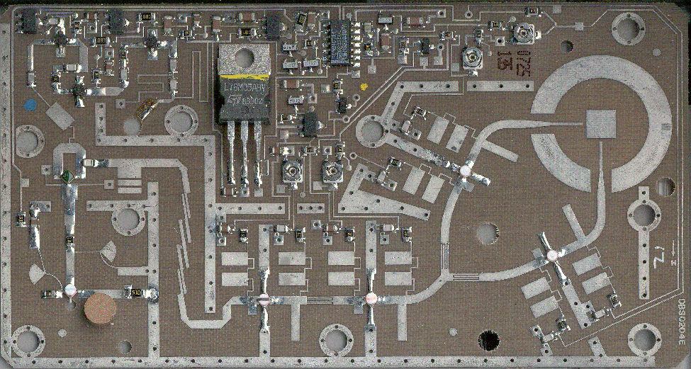
Figure 1 - LNB Board as removed from case.

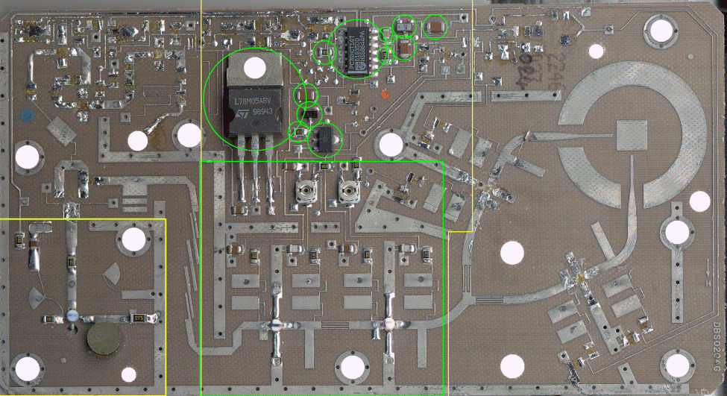
Figure 2 - Remove, but retain, all SM components outside of Green borders - Cut board on Yellow borders.

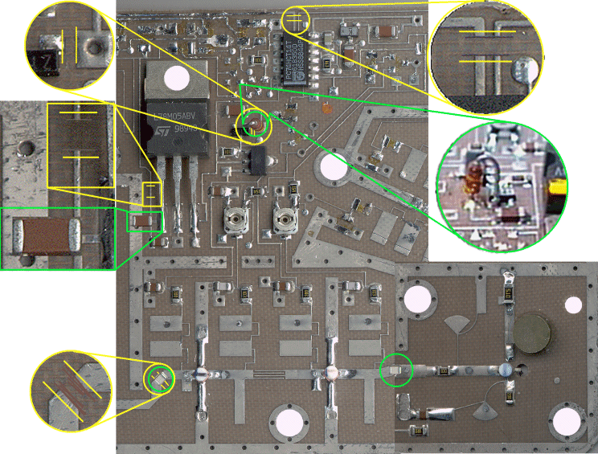
Figure 3 - Cut tracks at Yellow marks - Insert components within Green borders.

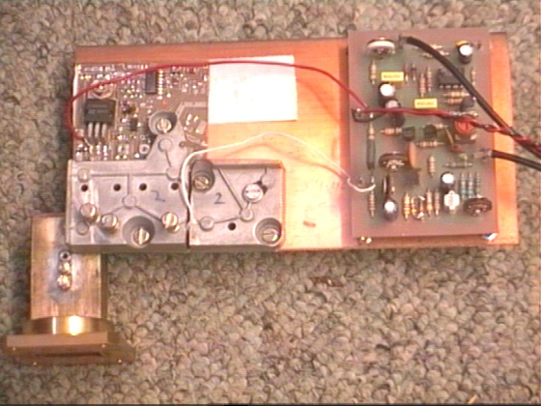
Figure 4 - Completed Tx.

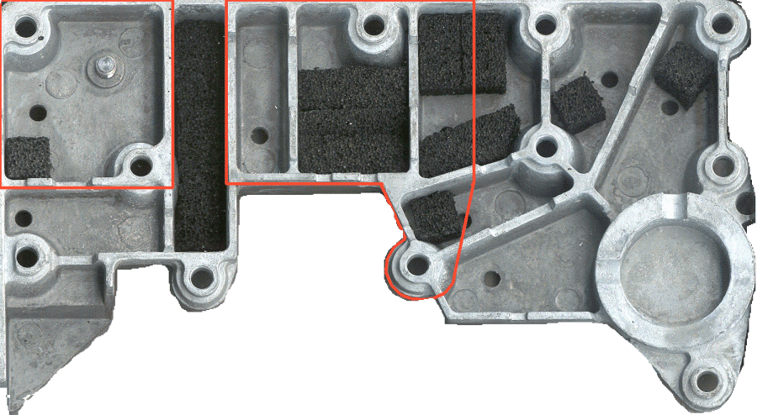
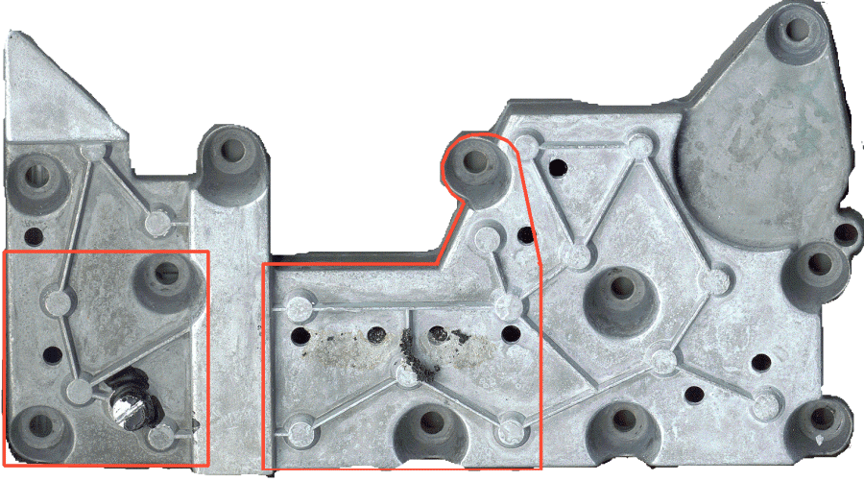
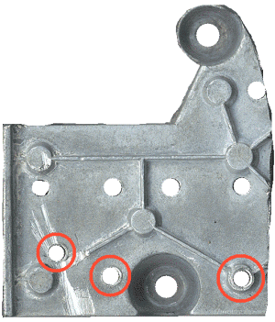
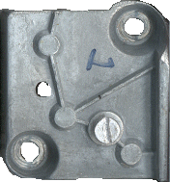
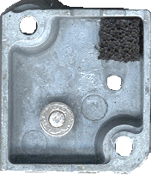
Figure 5 - Cut and drill screening case sections as shown.

Added washer to screw
A 3cms 50mW DRO Stabilised GaSFET Transmitter
Page 64 CQ-TV 181 © 1998 by the BATC
A 3cms 50mW D
By Bob Platts G8OZP
This novel and simple design provides a high quality ATV TX from a
surplus Marconi blue or black cap satellite LNB. The design provides a
useful power output level together with the improved stability of a DRO
(Dielectric Resonance Oscillator).
The output can, via a co-ax to waveguide transition, feed an antenna
directly, or may as in the authors unit, feed a two stage PA (RSGB
Microwave committee) which develops about 900mW.
The RF section is based on the modified internals from a Marconi blue cap
LNB. These can be found on the surplus market for as little as £1.00. The
modulator uses a slightly modified Gunnmod2 TX kit (less Gunn
oscillator) to process the video, regulate the supply and process and
produce the audio subcarrier signals. See the advert for Kits & Bits on
page 5. A power supply is also required. This could be built on the artwork
provided or on Veroboard.
By drilling remove the rivets from the LNB, then prise open. With an
Allan key remove the screws which locate the screening cover. Once the
cover has been removed, common sense static precautions must be
employed.
The PCB must be removed from the case. Cut or unsolder the wire link
from the F connector first. Some adhesive secures the PCB. Lift the PCB
at the end near the horn antenna, slide a screwdriver or similar object
under it and carefully prise the board out.
The local oscillator and the two stage RF amp needs to be cut from the
PCB. The lines drawn on Fig 1 indicates where the PCB should be cut
with sharp scissors.
Free off the tuning screw, which can be tight due to the sealant used. With
a hacksaw, cut out the section of the screening cover that goes over the
oscillator to form a screening cover complete with tuning screw.
With a small strip of thin copper or brass foil (this can sometime be found
inside the lids of old TV tuners) solder together the two ground planes of
the PCBs such that the output line from the oscillator matches up with the
input to the amp section. On the topside the output of the oscillator should
be coupled to the input of the amp by a surface mount capacitor removed
from the unused LNB PCB.
A 3cms 50mW DRO Stabilised GaSFET Transmitter
© 1998 by the BATC CQ-TV 181 Page 65
Use the capacitor marked Cap A on fig. 1. Carefully unsolder this from the
old board. The best way I have found is to apply fresh solder to the joints.
Then alternatively apply an iron to each end until they are both molten.
Then push the device to one side off the pads. Check the two tracks do not
touch each other. If they do cut back with a sharp knife, then solder the
cap in position. Remember static precautions.

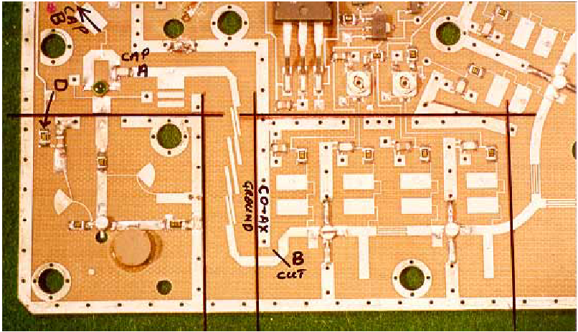

Fig. 1. Lines indicate where the board is cut with scissors. The points mentioned
in the text are also indicated.

From the old LNB PCB remove the capacitor marked Cap B. This is off
the top of fig. 1.
At the output end of the RF amp cut the track at the point B indicated in
fig. 1 and fit the cap across the cut to isolate the output from the FET
supply.
The RF output may be by either an SMA connector or via semi-rigid or
similar microwave co-ax.
For a SMA the body must be soldered directly to the bottom ground plane.
For co-ax, solder the outer along the top ground track indicated in fig. 1.
The exposed inner must be kept as short as possible.
The RF section must be mounted on the copper side of a piece of PCB that
is large enough to also accommodate the modulator and PSU board. The
Gunnmod 2 modulator PCB should be mounted such that the output is
fairly close by the supply input to the DRO oscillator.
A 3cms 50mW DRO Stabilised GaSFET Transmitter
Page 66 CQ-TV 181 © 1998 by the BATC
The PSU section should mount on the other side by the RF amp DC
inputs.
Secure the RF PCB by means of the three bolt holes available. The same
screws secure the screening cover for the oscillator. Also, secure the
amplifier section by means of four or five short pieces of tinned wire from
the top ground tracks down to the main PCB.

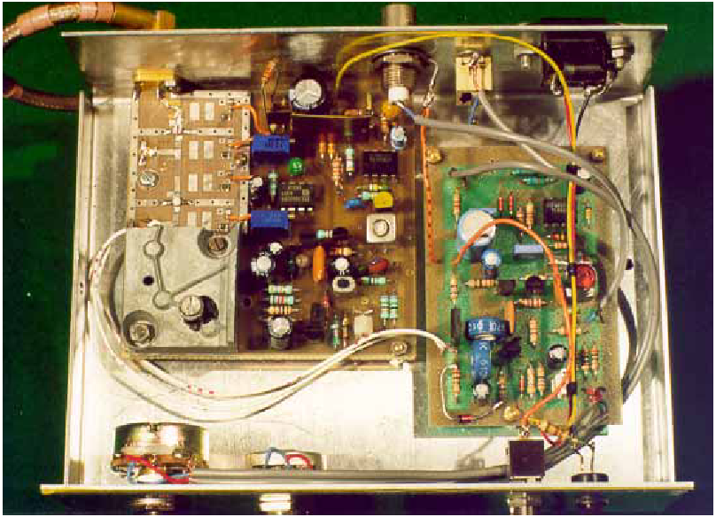
Fig. 2. Prototype unit. PCB in centre is Mk1, PSU with subcarrier oscillator.
In the Mk2 design the PSU is separate and Gummod2 PCB is used as
Modulator

Assemble the Gunnmod 2 PCB kit, replacing the 3v3 zener ZD1 with a
1N4148 diode. A 4.7v 1.3mW zener must be fitted across the output to
prevent the possibility of excessive voltage being applied and destroying
the oscillator FET.
The Gunnmod 2 peripheral 0 volts track must be connected to the main
PCB ground.
The connection from the modulator to the oscillator should be made with
fine wire. At the oscillator end make the supply connection onto the FET
A 3cms 50mW DRO Stabilised GaSFET Transmitter
© 1998 by the BATC CQ-TV 181 Page 67
supply decoupling capacitor at point D indicated on fig. 1. A small recess
in the screening cover allows the wire to exit from under the screening
cover. Do not make this connection until the output voltage of the
Gunnmod 2 PCB has first been set.
The PSU can be built on Veroboard. Again ensure a good ground
connection. The supply connections are again made with fine wire onto the
appropriate supply decoupling capacitor. From the oscillator end these are
in order VGl, VDl, VG2, VD2. Again these connections should not be
made until after the PSU voltages have been set.

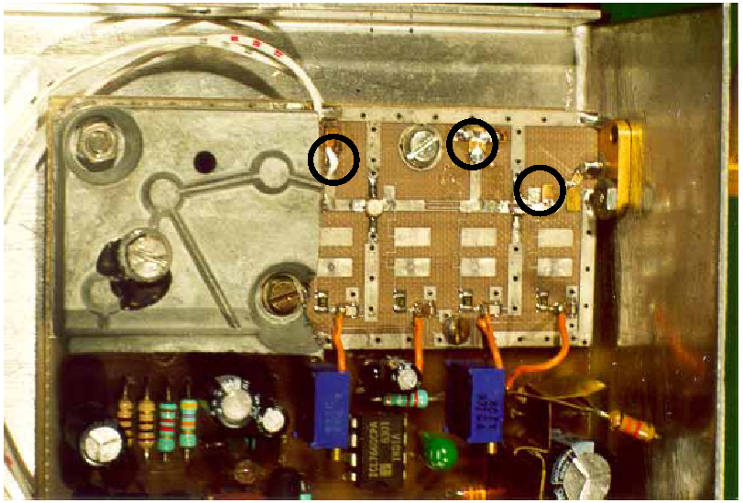
Fig. 3. Close up of the oscillator and PA showing the position of tuning foils.
(Circled). With care, 50mW output can be obtained.

SETTING UP. With VR1 (1k) on the PSU, set the FET supply voltage to
4 Volts. Set the two bias voltages by means of VR2 (10k) and VR3 (10k)
to 0.5 Volts.
Set the output voltage of the Gunmnod 2 PCB to 4 Volts. Other
adjustments on the Gunnmod 2 PCB are as in the kit instructions.
SETTING UP 2. (Very poor film industry joke)
A 3cms 50mW DRO Stabilised GaSFET Transmitter
Page 68 CQ-TV 181 © 1998 by the BATC
With a suitable load connected to the output apply power and video, adjust
the tuning screw on the oscillator for the desired frequency. Advance the
video gain control. A picture should be seen on a receiver.
The sound is set up as in the Gunnmod 2 instructions.
Some method of monitoring output power is required. An attenuater and a
diode detector are ideal. (See various microwave manuals). Alternatively a
detector diode held very close to the output may be used. (Take care not to
short out to anything)
Small brass or copper foils are required to tune the amplifier section. Fig.
3 shows the sizes and positions. They will need to be adjusted for
optimum output. A cocktail stick makes an ideal moving tool for fine
adjustment. When the positions for maximum output have been found,
solder in position with the minimum of solder. (Remember anti static
procedures)
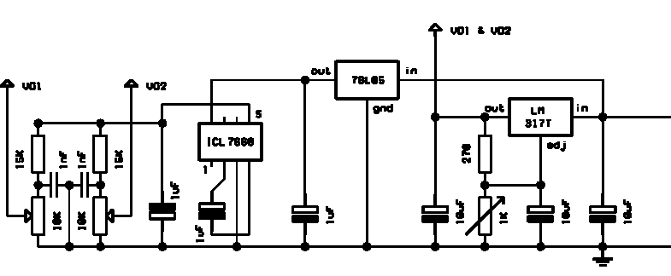
Power supply unit

Finally, adjust the bias voltages for max output.
With care and patience an output of 50mW will be achieved.
This design with minor modifications is also capable of transmitting data
at rates in excess of 4M-bits/sec. Details can be obtained from the author.
See the advert on page 5 for the address, and send an SAE requesting a
Gunmnod2 data mod.

